Cointegration and ECM: GBPUSD and USDCHF
Method 27 / Engle-Granger on log closes / one-lag ECM / Alpari D1 full available history

Study setup
Logical pair: PX=GBPUSD , PY=USDCHF
Broker symbols: GBPUSD_i , USDCHF_i
Snapshot: 2026-11-03_majors_alpari_D1
Timeframe: D1
Matched window: 1999-01-05 to 2026-11-02 (UTC bar dates)
Matched level count n: 7201
Dropped unfinished last bar dated 2026-11-03 UTC after a tick-volume check against the prior complete day.
ECM lags of deltas: 1
Complete matched rows (Excel): GBPUSD-USDCHF_Coint_D1.xlsx
Complete matched rows (HTML table): GBPUSD-USDCHF_Coint_D1_data.html

Method carried forward
Engle-Granger cointegration works on log price levels, not returns. For each unordered pair, PX is the left leg and PY the right leg. Step one: OLS ln(PY) = alpha + beta * ln(PX) + e. Step two: statsmodels Engle-Granger coint test on (ln(PY), ln(PX)). Error-correction: delta ln(PY)_t = c + kappa * e_{t-1} + lagged delta ln(PY) and delta ln(PX) (one lag each) + u_t. Headline is the Engle-Granger p-value (lower = stronger evidence of a stationary spread) with kappa and beta reported alongside. Same-sample Pearson r of log returns is a side check only. beta is not an automatic lot-size hedge. This is not a trading signal.

Results (headline)
alpha: -0.161244
beta: 0.570007
Engle-Granger t: -1.833772
Engle-Granger p: 0.613178
5% critical value: -3.336979
ECM kappa: -0.000682
kappa t-stat: -1.7139
ECM R^2: 0.002873
spread std: 0.194989
Pearson r (returns): -0.486083

Conclusion
Engle-Granger for PY=USDCHF on PX=GBPUSD: beta=0.5700, alpha=-0.1612, coint_t=-1.8338, p=0.6132 (5% crit=-3.3370). ECM kappa=-0.0007 (t=-1.71). Pearson r of returns = -0.4861. beta is not a lot-size hedge. Not a trading signal.

Charts
Daily closes

Engle-Granger residual spread
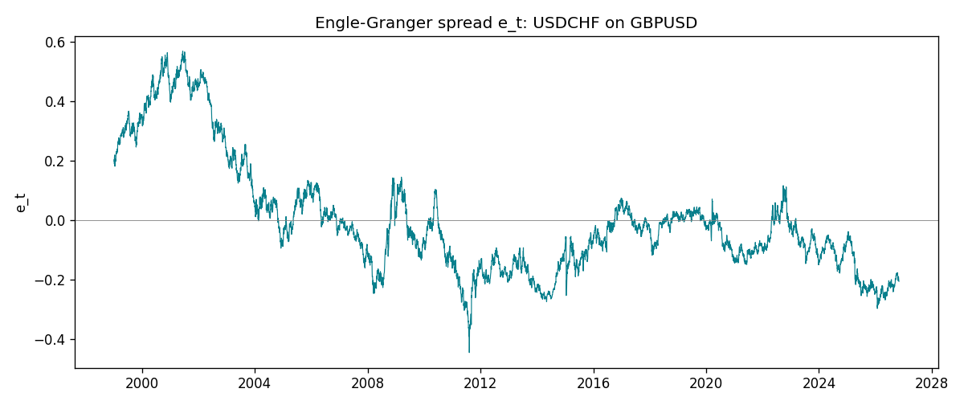
Daily log returns
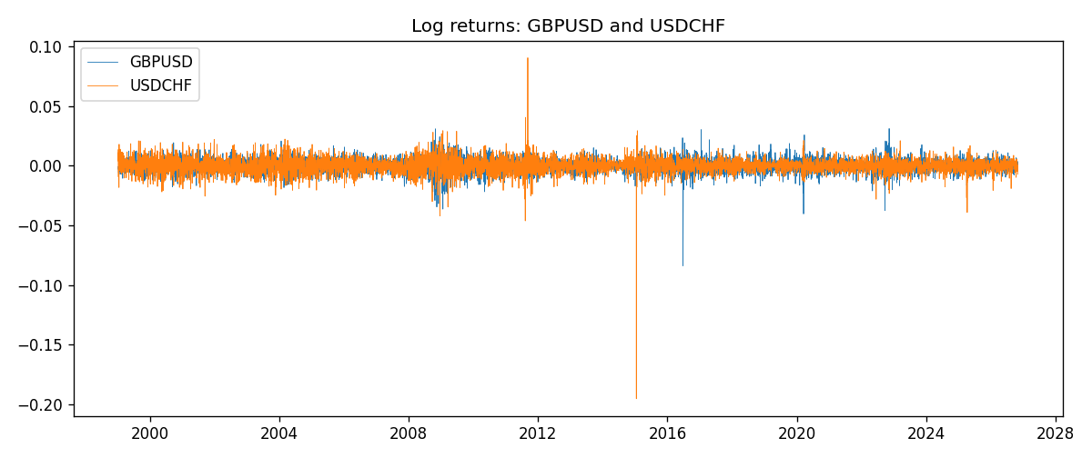

Data report
Matched rows are in the sibling Excel workbook named GBPUSD-USDCHF_Coint_D1.xlsx. Embedding all rows as a Word table is impractical; this file holds column summaries and the first and last 15 matched rows.
Column summaries
column | count | mean | std | min | 25% | 50% | 75% | max
GBPUSD_open | 7201 | 1.5160785 | 0.218271 | 1.06854 | 1.32499 | 1.51142 | 1.63167 | 2.1066
USDCHF_open | 7201 | 1.0982956 | 0.25264095 | 0.72022 | 0.92069 | 0.99019 | 1.2387 | 1.8219
GBPUSD_high | 7201 | 1.5223771 | 0.21884011 | 1.08366 | 1.32979 | 1.5182 | 1.6384 | 2.1161
USDCHF_high | 7201 | 1.1035944 | 0.25438893 | 0.73305 | 0.92495 | 0.99377 | 1.2436 | 1.8313
GBPUSD_low | 7201 | 1.5097512 | 0.21749696 | 1.03518 | 1.31949 | 1.50336 | 1.6244 | 2.0983
USDCHF_low | 7201 | 1.0931703 | 0.25105533 | 0.08565 | 0.91742 | 0.9867 | 1.2331 | 1.8121
GBPUSD_close | 7201 | 1.5161456 | 0.2182303 | 1.06879 | 1.3251 | 1.5114 | 1.63212 | 2.1065
USDCHF_close | 7201 | 1.0982864 | 0.25254184 | 0.72025 | 0.92098 | 0.9902 | 1.2387 | 1.8217
GBPUSD_tick_volume | 7201 | 94828.085 | 153546.21 | 62 | 10002 | 52900 | 91806 | 1273370
USDCHF_tick_volume | 7201 | 74189.26 | 113409.95 | 18 | 12770 | 40195 | 70240 | 858589
GBPUSD_spread | 7201 | 26.971115 | 19.193539 | 0 | 11 | 20 | 50 | 50
USDCHF_spread | 7201 | 26.114567 | 24.723753 | 0 | 5 | 16 | 50 | 100
GBPUSD_real_volume | 7201 | 3.5560898e+09 | 8.4438214e+10 | 0 | 0 | 0 | 0 | 2.4038164e+12
USDCHF_real_volume | 7201 | 2.3236557e+10 | 8.9041498e+10 | 0 | 0 | 0 | 0 | 1.9331921e+12
GBPUSD_log_price | 7201 | 0.40612213 | 0.14086343 | 0.06652717 | 0.28148793 | 0.41303637 | 0.48987978 | 0.7450278
USDCHF_log_price | 7201 | 0.07024829 | 0.21087398 | -0.32815691 | -0.08231696 | -0.00984834 | 0.21406244 | 0.59977013
GBPUSD_log_return | 7201 | -2.316e-05 | 0.00564524 | -0.08388241 | -0.00312969 | 3.242e-05 | 0.00318104 | 0.03112653
USDCHF_log_return | 7201 | -7.148e-05 | 0.00659332 | -0.19545699 | -0.00335964 | 8.06e-05 | 0.00331782 | 0.09051364
spread_e | 7201 | -0 | 0.19498934 | -0.44591711 | -0.12817914 | -0.03629612 | 0.05446052 | 0.56938115
ecm_fitted | 7200 | -7.203e-05 | 0.00035342 | -0.00458208 | -0.00025222 | -6.314e-05 | 0.00010868 | 0.01121643
First 15 matched rows (selected columns)
time | GBPUSD_log_price | USDCHF_log_price | spread_e | GBPUSD_log_return | USDCHF_log_return
1999-01-05 | 0.50361972 | 0.31656103 | 0.19073842 | -0.0028966287 | 0.0039424743
1999-01-06 | 0.5030152 | 0.33016668 | 0.20468865 | -0.00060452184 | 0.013605652
1999-01-07 | 0.50089649 | 0.3207783 | 0.19650795 | -0.002118709 | -0.0093883841
1999-01-08 | 0.49500107 | 0.33181857 | 0.21090865 | -0.0058954193 | 0.011040268
1999-01-11 | 0.48931594 | 0.33711489 | 0.21944553 | -0.0056851331 | 0.0052963193
1999-01-12 | 0.49158164 | 0.32728733 | 0.20832651 | 0.0022657001 | -0.0098275602
1999-01-13 | 0.50071468 | 0.30902763 | 0.18486091 | 0.0091330396 | -0.018259701
1999-01-14 | 0.50265231 | 0.30660196 | 0.18133077 | 0.0019376331 | -0.0024256692
1999-01-15 | 0.50089649 | 0.32454424 | 0.20027388 | -0.0017558204 | 0.01794228
1999-01-18 | 0.50210773 | 0.3213586 | 0.19639783 | 0.0012112405 | -0.0031856384
1999-01-19 | 0.50398226 | 0.32128608 | 0.19525682 | 0.0018745281 | -7.2518946e-05
1999-01-20 | 0.49907688 | 0.32851207 | 0.20527891 | -0.0049053846 | 0.0072259871
1999-01-21 | 0.50222878 | 0.3246888 | 0.19965903 | 0.0031518998 | -0.0038232689
1999-01-22 | 0.50470694 | 0.32454424 | 0.1981019 | 0.0024781662 | -0.0001445609
1999-01-25 | 0.50591358 | 0.32699893 | 0.19986881 | 0.0012066366 | 0.0024546976
Last 15 matched rows (selected columns)
time | GBPUSD_log_price | USDCHF_log_price | spread_e | GBPUSD_log_return | USDCHF_log_return
2026-10-13 | 0.28166903 | -0.18339413 | -0.18270327 | 0.0036434319 | -0.0024955621
2026-10-14 | 0.27675256 | -0.1804553 | -0.17696201 | -0.0049164679 | 0.0029388325
2026-10-15 | 0.2833502 | -0.19024083 | -0.19050825 | 0.0065976411 | -0.0097855323
2026-10-16 | 0.28710941 | -0.19386391 | -0.1962741 | 0.0037592051 | -0.0036230826
2026-10-19 | 0.28535938 | -0.19022874 | -0.1916414 | -0.0017500314 | 0.0036351779
2026-10-20 | 0.29095172 | -0.19285686 | -0.19745719 | 0.0055923442 | -0.0026281224
2026-10-21 | 0.29219935 | -0.19325713 | -0.19856863 | 0.0012476328 | -0.00040027413
2026-10-22 | 0.29242331 | -0.19806077 | -0.20349992 | 0.00022396082 | -0.0048036381
2026-10-23 | 0.29030862 | -0.19240826 | -0.19664202 | -0.0021146949 | 0.005652514
2026-10-26 | 0.28787455 | -0.19056746 | -0.19341379 | -0.0024340661 | 0.0018407959
2026-10-27 | 0.28550971 | -0.18795741 | -0.18945576 | -0.0023648393 | 0.0026100526
2026-10-28 | 0.2870869 | -0.18897162 | -0.19136898 | 0.0015771808 | -0.0010142111
2026-10-29 | 0.29067509 | -0.19383964 | -0.19828229 | 0.0035881935 | -0.0048680164
2026-10-30 | 0.29202015 | -0.19312369 | -0.19833304 | 0.0013450605 | 0.00071594559
2026-11-02 | 0.29311727 | -0.20026966 | -0.20610438 | 0.0010971256 | -0.0071459744

